November 3,2023

**The Managing Director**

**Greenwich Merchant Bank Limited**

1698A Oyin Jolayemi Street

Victoria Island

Lagos

Dear Sir,

**RIGHTS ISSUE OF UP TO NGN40 BILLION BY WEMA BANK PLC**

I, Yewande Zaccheaus hereby appoint Mr. Johnson Lebile as my agent, to sign on my behalf the Rights Circular, and any other document to be filed with the Securities & Exchange Commission and other regulatory bodies in respect of the above transaction.

Dated this 3rd day of November, 2023

Signed by: 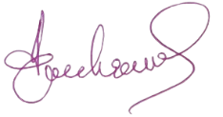

**In the presence of:**

Signature: ...................................................................................

Name: ........................................................................................

Address: ....................................................................................

Occupation: ...............................................................................